UNIT III
TEXTURE IN FOODS
According to Matz (1962), texture can be defined as the mingled experience derived from the sensation of skin in the mouth after ingestion of food or beverage. What we sense as texture in foods, derives from the physical characteristics of these materials. We generally concern ourselves with hardness of tough meat, softness of tender jellies, chewiness of steak, thickness of sauces, elasticity of bread, sticky surface of caramel, roughness of salt crystals etc. to realize how many characteristics provide textural stimuli in foods. In other words, texture is a composite property involving many physical properties in a complex relationship or in a more general way, texture can be defined as a way in which various constituents and structural components are arranged and combined into a micro and macro structure and the external manifestation of the structure in terms of flow. The formation texture influences:
(1) Consumer acceptability,
(2) Type of packaging, and
(3) Processing method (Power required).
We learnt earlier that texture is observed in terms of tactile sensations i.e. fingerfeel and mouthfeel. Finger feel is sensed before ingestion, by pressing and touching, e.g. to detect the freshness or staleness of bread by handfeel. On the other hand, once you ingest the food the mixed feeling derived mainly due to the activation of palate and teeth, is the mouthfeel. During chewing, various kinds of forces are applied which tell us about the texture of the food. The forces are compression, cutting, tensile strength and shearing. These same kinds of forces are imitated in the objective evaluation of textural properties. The term ‘mouthfeel’ can therefore be defined as the mingled experience arising from the sensation of the skin and the mouth during and after ingestion.
You may be wondering why a study of the food texture is important. The study of food texture is important for three reasons:
1. To evaluate the resistance of product against mechanical action such as in mechanical harvesting of fruits and vegetables,
2. To determine the flow properties of a product (what is referred to as rheology) during processing, handling and storage, and
3. To establish the mechanical behaviour of food when consumed.
Next, how do we measure food texture? Food texture can be evaluated by mechanical test or instrumental methods. This is called as objective evaluation. When we use the human sensory organs as analytical tools, we call it the sensory or subjective evaluation. For the purpose of measurement, however, classification in terms of physical properties has been proposed by Szczesmiac in 1963. This system groups the characteristics as mechanical (hardness, cohesiveness, viscosity, elasticity, adhesiveness), geometrical (particle size, shape and orientation) and others (moisture content, fat content) as highlighted in Table.

Table: Different Textural Parameters and their popular classification (Szczezmiac Classification (1963)
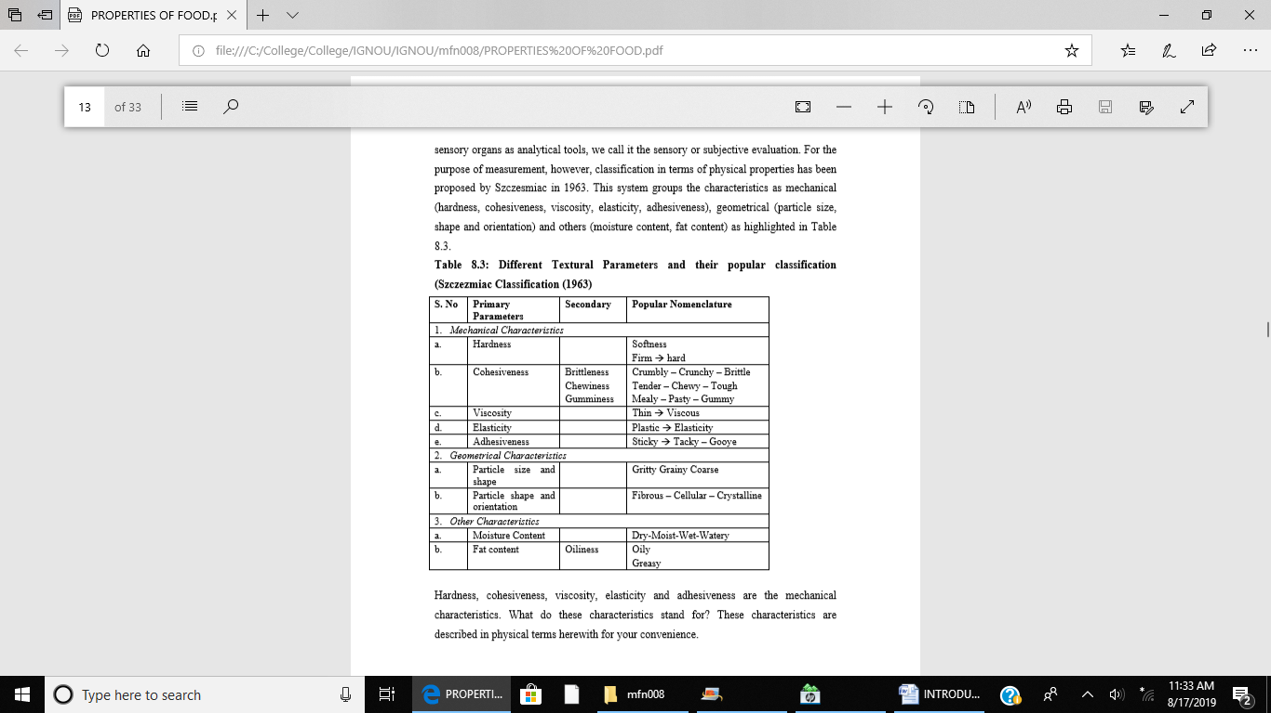
Hardness, cohesiveness, viscosity, elasticity and adhesiveness are the mechanical characteristics. What do these characteristics stand for? These characteristics are described in physical terms herewith for your convenience
Hardness: It is defined as the force necessary to affect a given deformation. When judged by human senses, it is the force required to penetrate a food with molar teeth. Solids and some semi-solids have this property. For example, Cream cheese is low in hardness and raw candy is very hard.
Cohesiveness: It derives from the strength of internal bonds holding the body of the substance together. Cohesiveness, being the primary characteristic includes - brittleness, chewiness and gumminess – as the secondary characteristics. What are these characteristics? Let us know. Brittleness is judged by the taster as the ease with which the food can be cracked, then shattered or crumbled. Chewiness can be defined as the resistance of a product to compression and shearing action of teeth or the energy needed to masticate a solid food and gumminess can be understood to include the resistance offered by food when teeth/tongue are withdrawn after first penetrating the food i.e. the energy required to disintegrate a semi-solid food prior to swallowing.
Viscosity: It is measured as the rate of flow per unit force. The resistance of liquids to flowing is readily observed and is usually conveniently measured. For example, in the mouth, it is sensed as ‘body’ or thickness by small variation of resistance against the sensitive touch receptors of lips, cheeks, palate and tongue.

Elasticity: It is defined as the rate at which a deformed material goes back to its original shape. Elasticity is difficult to measure independently of other parameters. It is a part of chewiness.
Adhesiveness: It is measured as the work necessary to overcome the attractive forces between surfaces of material and surfaces that contact it. In eating, this property is sensed between food surfaces and mouth/throat tissues. For example, oil allows little adhesion, while peanut butter much.
All these textural characteristics discussed above are the working basis for food researchers, quality control experts and engineers busy in developing instruments to measure texture. In this section, we will study about objective evaluation of food texture. How is the food texture measured? What are the different methods and instruments used for measuring texture of different foods?
Objective Measurement and Evaluation of Food Texture
Kinesthetic characteristics deal with the sense of feel, just like the characteristics of appearance deal with the sense of sight.
Objective methods of textures measurement involve simulating and measuring the sensations which the consumer experiences through the sense of feel with the fingers and more precisely in the mouth.
Many of these instruments used to measure texture, involve measurement of resistance to the force applied which is measured in terms of grams/kilograms force. This force may be applied in a number of ways or through a combination of two or more of the methods highlighted herewith. Basically four types of forces are encountered, which include:
Four Types of basic forces
1. Compression: This refers to the squeezing of the test material so that it still remains as a single undivided unit but may occupy less volume. For e.g. finger test and pressure test to measure the juiciness, firmness etc.
2. Cutting – This occurs when the force is applied in such a way that the test unit is divided so that the portions in the original position in relation to each other.
3. Shearing – This results from the application of force where the test material is separated to two or more parts, with one part sliding beyond the other part e.g. separating dough into two parts.
Shearing 4. Tensile strength – This is the application of force away from the material rather than towards the material, when a force is applied to pull the test material apart. There may be one force or combination of two forces, such as shear pressure. Shear Pressure – Both shearing and compression. The food is first compressed, then sheared for example tenderometer, chewing action of teeth etc.
Earlier we learnt that the textural properties include mechanical properties of hardness, cohesiveness, adhesiveness, chewiness, crispness, gumminess, viscosity and elasticity etc. A number of instruments are available to evaluate the texture of various foods. A brief discussion on these instruments follow.

Considering the various textural characteristics of food, you will find that different instruments are used to measure their different mechanical characteristics.
A few examples are: (i) the tenderness of meat is tested by measurement of structure of meat with a penetrometer. This measurement gives an idea of how easy or difficult it is for the teeth to bite into a piece of meat. Another device used to measure tenderness is Warner Braztler Shear. This measures the force needed to cut the meat in simple shear usually across the fibres and estimate the force needed to chew the meat.
(ii) The texture of fruits and vegetables can be measured as follows:
a) Punctured testing is used to evaluate firmness of fruits. It measures the amount of force required to penetrate the sample to a specific depth.
b) A shear press is used to study tenderness of fruits and vegetables. This consists of a rectangular box with evenly spaced slits at bottom. A series of blades is moved through a sample of food. As the blades move, food is compressed, sheared and extruded through the openings in box.
(iii) The texture of doughs and batters determine the quality of finished product. Consistency of batters is determined by “Line-spread apparatus”, which indicates the nature of dispersion of incorporated air. Consistency and stability of doughs are measured with a “farinograph”, which measures the force required to turn mixer blade at a constant speed during mixing of the dough. A “mixograph” also gives information similar to farinographs.
(iv) Texture of baked products - pastries, cookies and crackers is determined by “shortometer”. It measures the force required to break the products. A “compressimeter” is used to evaluate the firmness of breadcrumbs or softness of baked products. The force requires to break through a sample of baked product can be measured using “WarnerBraztler Shear”.
Textures, as perceived by human beings, is a composite of characteristics to arrive at a textural profile. Different new instruments have been developed to evaluate more than one characteristic constituting texture of a food. One such multiple measuring devices – Instron – texture measuring system, can measure many properties at the same time e.g.
firmness, grittiness, case hardening etc. by the use of force and time curves. In this, force and time are varied simultaneously. For surface hardening a steep rise is obtained in the curve. For a less firm product, there will be a gradual rise. For gritty particles, a number of sharp peaks depths are observed.
Some characteristics of food depend on rheological properties. What are these properties? What do we mean by rheology of food? The next section presents a discussion on food rheology.
Rheology of Foods
Rheology is the study of stress and strain or in other words, it is the study of flow and deformation of materials, both liquids and solids, under stress and strain conditions. Primarily, rheology deals with three aspects –Elasticity, Plasticity and Viscosity.

The flow characteristics of a food are actually quite complex. For example, if a bread dough is stretched, but not too far, it will spring back; to the extent that it does, the dough is elastic. Elasticity is a characteristic of importance in baked products too. Such as crumb of bread and cake, especially so when they are fresh.
Elastic deformation is reversible but plastic is not. A material that exhibits plastic flow resists changing position until a minimum force is applied. This is a desirable characteristic in cake frosting. A soft frosting is desired, but it should stay in place but not flow down the sides of the cake.
Solids do not flow; however, some solids can be deformed by force and recover when the force is removed. This is elasticity and gels like those of pectin, gelatin and starch baked custard etc. are examples of elastic solids. There a number of objectives tests to determine the firmness of gels. A material that is plastic resists flow until a force is applied but unlike elastic flow, plastic flow is irreversible.
What is viscosity?
Viscosity is resistance to flow of a liquid. It is a measure of the resistance of a fluid to deformation under shear stress. It is commonly perceived as "thickness", or resistance to pouring. Viscosity describes a fluid's internal resistance to flow and may be thought of as a measure of fluid friction. Thus, water is "thin", having a low viscosity, while vegetable oil is "thick" having a high viscosity. While studying about viscosity you will come across terms such as newtonian fluid and non-newtonian fluids. What do we mean by this? A Newtonian fluid is one in which the viscosity does not depend on the shear rate—no matter what shear is applied, the viscosity stays the same. Examples of newtonian liquids are mineral oil, water and molasses. In many applications, however, this is not the case and, as the fluid is sheared at greater rates, the viscosity will change. These types of liquids are known as non-newtonian and there are many classifications. Examples are toothpaste and whipped cream.
Various methods for textural or rheological measurement are used. We will not go into the details of these methods here in this unit, but certainly highlight a few method used to measure rheological parameters.
The first type of rheological model highlighted here is Dash pot model.
1. Dash Pot Model: This method establishes relation between the pressure gradient and the volume rate of flow. Here, the piston measurement is used to measure the consistency of the product present in the cylinder. If the load required is more, consistency is thick. It consists of a piston sliding in the cylinder filled with oil as shown in the figure 8.5. Here, the load is connected with piston, as you can see from the figure 8.5, which provides the force for piston movement. If the viscosity is high, more load is required to obtain a constant movement. Oil can be replaced by the food material for which the measurements are to be taken. The initial period of no deformation is there. The piston starts moving only after a critical load is applied. After sometime, the deformation remains constant. This model can be used only for fluid test products.
2. Spring Model The spring model depicts elasticity. A force is applied in terms of load onto the spring as illustrated in the figure 8.6. When the force is applied, deformation is produced which will remain constant for sometime and the spring will immediately regain its shape after removal of a load.
This is ideal for the elastic materials. In case of food, the spring is replaced with food material or elastic food, for which the deformation is to be measured. For example, extensiometer for measuring the dough elasticity and extensibility.

3. Spring clip model: The spring clip model differs from the spring model in a way that the force applied is comparatively slower. This also depicts elasticity or plasticity of a material. The force is controlled by pulley arrangement. It is used for measuring the breaking strength of dough. Initially, for sometime, it resists the flow. Once started with the deformation and after completion of deformation, it becomes still.
4. Shear Pin Model: In this type, a shearing force is applied using a pin to shear the food product, as illustrated in the figure 8.8. We are rupturing the element of the food product by using pin.

GLOSSARY:
Absolute threshold : The minimum detectable concentration; stimulus magnitude at which the subject an identify different tastes.
Adhesiveness : The work necessary to overcome the attractive forces between surfaces of material and surfaces that contact it.
Bitterness : A sensation of a peculiar, acid, biting taste.
Brittleness : The ease with which a food can be cracked.
Chewiness : The resistance of a product to compression and shearing action of teeth.
Cohesiveness : The strength of internal bonds holding the body of the substance together.
Colour : The characteristic of light that is measured in terms of intensity and wavelength.
Compression : The squeezing of the test material so that it still remains as an undivided unit but may occupy less volume.
Disc Colourimetry : A technique by which an unknown colour is evaluated in terms of standard colours; used in chemistry and physics; may be visual, photoelectric, or indirect by means of spectrophotometry. Dissociation : The process that may occur when a chemical compound breaks up into simpler constituents as a result of an action of a solvent or a change in physical condition, as in pressure or temperature, causes a molecule to split into simpler groups of atoms, single atoms, or ions.
Elasticity : The rate at which a deformed material goes back to its original shape.
Emulsifying agents : An agent used to bind oil soluble and water soluble ingredients.
Flavour : A combination of taste and odour or smell or aroma.
Gas chromatography : The separation of a mixture of compounds into separate components, which then can be analyzed by a mass spectrometer to yield detailed empirical molecular information regarding chemistry of sample.
Gas Liquid Chromatography : The substance is held stationary by an inert solid coated with an inert liquid which is not likely to evaporate, while a gas flows past it bringing out the components one at a time.
Grades : A set of things all falling in the same specified limits; a class.
Gumminess : The energy required to disintegrate a semi-solid food prior to swallowing.
Gustation : An act of tasting.
Luminosity : The quality of being luminous; emitting or reflecting light.
Mouthfeel : The mingled experience desiring from the sensation of the skin and the mouth during and after ingestion.
Objective Evaluation : Evaluation by mechanical test or instrumental methods.
Odour : The sensation that results when olfactory receptors in the nose are stimulated by particular chemicals in a gaseous form.
pH meter : A device used to measure hydrogen ion concentration or pH.
Quality : A degree of excellence and includes such things as taste, appearance and nutritional content. It is the composite of characteristics that have significance and which help in making the product acceptable.
Reaction time : The time interval between tasting of a substance and identification of the taste by the brain.
Recognition/Detection Rheology : Study of stress and strain; the study of flow and deformation of materials, both liquids and solids under stress and strain conditions.
Sensory evaluation : When the quality of a food product is assessed by means of human sensory organs.
Shearing : The application of force where the test material is separated to two or more parts with one part sliding beyond the other part.
Spectrophotometer : An instrument for measuring or comparing the intensities of the colours of the spectrum.
Tensile strength : The application of force away from the material rather than towards the material. Terminal Threshold : The maximum concentration beyond which taste or a change in sensation is not perceived.
Texture : A composite properly involving many physical properties in a complex relationship.
Threshold : The concentration required for identification.
Stimulus Threshold : The concentration at which the subject can identify a specific taste. It is always higher than absolute threshold.
Tintometer : A measuring instrument used in colorimetric analysis to determine the quantity of a substance from the colour it yields with specific reagents.
Viscosity : The rate of flow per unit force.
Wavelength : The distance between successive peaks or nodes of a wave.

