BASES OF MARKET SEGMENTATION :

1. BASES FOR SEGMENTATION IN CONSUMER MARKETS :

1. GEOGRAPHIC SEGMENTATION:
Geographic segmentation refers to dividing a market into different geographical units such as nations, states, regions, cities, or neighbourhoods.

For example, national newspapers are published and distributed to different cities in different languages to cater to the needs of the consumers.

Geographic variables such as climate, terrain, natural resources, and population density also influence consumer product needs. Companies divide markets into regions because the differences in geographic variables can cause consumer needs and wants to differ from one region to another.

Claritas Inc has developed a geoclustering approach called PRIZM (Potential Rating Index by ZIP Markets ) that classifies over half a million people into 14 distinct groups.

Marketers use PRIZM to answer questions like :
- Which geographic areas contain most valuable customers ?
- How deeply have we penetrated the markets?
- Which distribution and promotional media will work best ?

EXAMPLES : GEOGRAPHIC SEGMENTATION :
1.Climate:
A company that sells both rain gear and summer wear has to consider weather changes while marketing such products.
It has to focus on marketing rain wear in rainy regions and summer wear in places with hot weather.
This strategy is mainly applicable for those sellers, who have customers in various locations with different climatic conditions. So, geographic segmentation is very important in international marketing.
2. Population Density:
Certain products are marketed on the basis of population density in different locations. High-density cities, like New York, create a higher demand for products, like ready-to-eat meals. Even fast food restaurants are commonly found in such cities, rather than urban areas.
GEOGRAPHIC SEGMENTATION :-
ADVANTAGES | LIMITATIONS
1. Valuable approach for a large company that operates across many countries, as geographic segmentation would allow them to consider cultural differences.  2. It is also quite an effective approach for small firms, with limited resources that often need to operate in a defined geographic area for efficiency purposes. | 1. This segmentation base is quite limited as it assumes that all consumers in a geographic area are similar in needs.  2. Geographic segmentation typically needs to be used in conjunction with another segmentation base .

2. DEMOGRAPHIC SEGMENTATION :
Demographic segmentation divides the markets into groups based on variables such as age, gender, family size, income, occupation, education, religion, race and nationality.
Demographic factors are the most popular bases for segmenting the consumer group. One reason is that consumer needs, wants, and usage rates often vary closely with the demographic variables. Moreover, demographic factors are easier to measure than most other type of variables.

1. Age:
It is one of the most common demographic variables used to segment markets. Some companies offer different products, or use different marketing approaches for different age groups.
For example, McDonald’s targets children, teens, adults and seniors with different ads and media. Markets that are commonly segmented by age includes clothing, toys, music, automobiles, soaps, shampoos and foods.

2. Gender:
Gender segmentation is used in clothing, cosmetics and magazines.
EXAMPLE-
Lakme sells beauty care products to women .

3. Income:
Income is used to divide the markets because it influences the people’s product purchase. It affects a consumer’s buying power and style of living.
Income includes housing, furniture, automobile, clothing, alcoholic, beverages, food, sporting goods, luxury goods, financial services and travel.
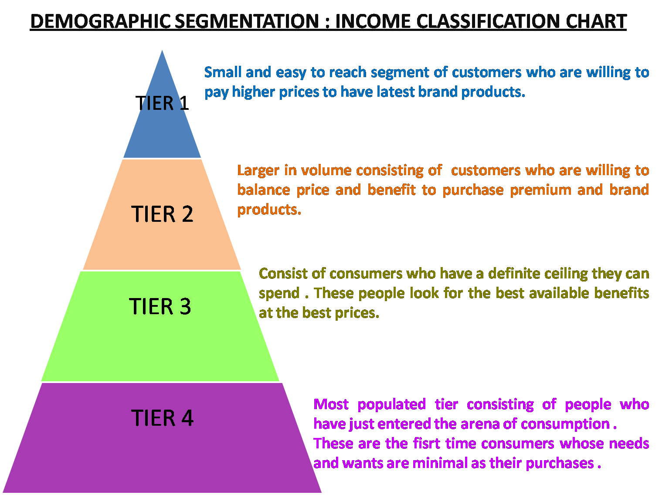

4. Family cycle:
Product needs vary according to age, number of persons in the household, marital status, and number and age of children.
These variables can be combined into a single variable called family life cycle.
Housing, home appliances, furniture, food and automobile are few of the numerous product markets segmented by the family cycle stages.
Social class can be divided into upper class, middle class and lower class. Many companies deal in clothing, home furnishing, leisure activities, design products and services for specific social classes.
DEMOGRAPHIC SEGMENTATION :-
ADVANTAGES :

1. The demographic information that will help business segment the market is easily accessible through census data.
2.Using demographic segmentation also leads to customer retention and loyalty.
3. It will save the time and money in the long run, because efforts to expand business will be carefully calculated and to the point.
LIMITATIONS :
1. If company don’t have a clear idea from the very beginning about what their goals are, there is waste of time and efforts chasing after the wrong market segment.
2. While trying to move certain products, marketers may overlook a particular group of potential customers.

3. PSYCHOGRAPHIC SEGMENTATION:
Psychographic is the science of using demographics to understand consumers better .
This segmentation pertains to lifestyle and personality traits. In the case of certain products, buying behaviour predominantly depends on lifestyle and personality characteristics.
One of the most popular commercially available systems based on psychographic measurement is SRI consulting Business Intelligence's Framework . (SRIC-BI) VALS™.
VALS signify values , attitudes and lifestyle .
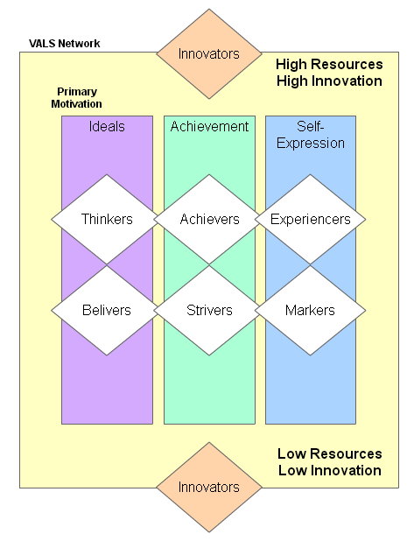

Primary Motivation: Ideals, Achievement, and Self-Expression
The concept of primary motivation explains consumer attitudes and anticipates behavior. VALS includes three primary motivations that matter for understanding consumer behavior: ideals, achievement, and self-expression.
- Consumers who are primarily motivated by ideals are guided by knowledge and principles.
- Consumers who are primarily motivated by achievement look for products and services that demonstrate success to their peers.
- Consumers who are primarily motivated by self-expression desire social or physical activity, variety, and risk.
These motivations provide the necessary basis for communication with the VALS types and for a variety of strategic applications.

Resources
A person's tendency to consume goods and services extends beyond age, income, and education.
Energy, self-confidence, intellectualism, novelty seeking, innovativeness, impulsiveness, leadership, and vanity play a critical role.
These psychological traits in conjunction with key demographics determine an individual's resources. Various levels of resources enhance or constrain a person's expression of his or her primary motivation.
THE 4 GROUPS WITH HIGH RESOURCES:
1. Innovators.
These consumers :
- The leading edge of change Have the highest incomes
- High self-esteem Successful , Sophisticated.
- Image is important to them as an expression of taste, independence, and character. Their consumer choices are directed toward the "finer things in life."
2. Thinkers.
These consumers are :
- The high-resource group of those who are motivated by ideals. They are mature, responsible, well-educated professionals.
- Their leisure activities center on their homes, but they are well informed about what goes on in the world and are open to new ideas and social change.
- They have high incomes but are practical consumers and rational decision makers.
3. Achievers.
- These consumers are the high-resource group of those who are motivated by achievement.
- They are successful work-oriented people who get their satisfaction from their jobs and families.
- They are politically conservative and respect authority and the status quo.
- They favor established products and services that show off their success to their peers.
4. Experiencers.
- These consumers are the high-resource group of those who are motivated by self-expression.
- They are the youngest of all the segments, with a median age of 25.
- They have a lot of energy, which they pour into physical exercise and social activities.
- They are avid consumers, spending heavily on clothing, fast-foods, music, and other youthful favorites, with particular emphasis on new products and services.
THE 4 GROUPS WITH LOWER RESOURCES:
1. Believers.
- These consumers are the low-resource group of those who are motivated by ideals.
- They are conservative and predictable consumers who favor local products and established brands.
- Their lives are centered on family, community, and the nation. They have modest incomes.
2. Strivers.
- These consumers are the low-resource group of those who are motivated by achievements.
- They have values very similar to achievers but have fewer economic, social, and psychological resources.
- Style is extremely important to them as they strive to emulate people they admire.
3. Makers.
- These consumers are the low-resource group of those who are motivated by self-expression.
- They are practical people who value self-sufficiency.
- They are focused on the familiar-family, work, and physical recreation-and have little interest in the broader world.
- As consumers, they appreciate practical and functional products.
4. Survivors.
- These consumers have the lowest incomes.
- They have too few resources to be included in any consumer self-orientation and are thus located below the rectangle.
- They are the oldest of all the segments, with a median age of 61.
- Within their limited means, they tend to be brand-loyal consumers.
PSYCHOGRAPHIC SEGMENTATION :-
ADVANTAGES | LIMITATIONS
1. Psychographic segmentation gives a much better insight into the consumer as a person, which gives better identification of the underlying needs and motives.  2. It delivers a much better understanding of the consumer, which in turn create more valid and responsive segments and subsequent marketing programs. | 1.It requires the organization to have detailed data/research on the consumer. Hence it is far more suitable for a larger organization and is probably beyond the scope of a small business  2. There are also some concerns regarding data and interpretation, and perhaps the creation of segments that cannot be easily accessed or practical in real life.

4. BEHAVIOURAL SEGMENTATION :
In behavioural segmentation, buyers are divided into groups on the basis of their knowledge of, attitude towards, use of, or response to a product.
Behavioural segmentation includes segmentation on the basis of :

1. Occasion:
Buyers can be distinguished according to the occasions when they purchase a product, use a product, or develop a need to use a product. It helps the firm expand the product usage.
Example :
1.Cadbury’s advertising to promote the product during wedding season is an example of occasion segmentation.
2. The Indian festivals like Diwali , Rakshabandhan sweets are sold at high prices .

2. User status:
Sometimes the markets are segmented on the basis of user status, that is, on the basis of non-user, ex-user, potential user, first-time user and regular user of the product.
Large companies usually target potential users, whereas smaller firms focus on current users.

3. Usage rate:
Markets can be distinguished on the basis of usage rate, that is, on the basis of light, medium and heavy users.
Heavy users are often a small percentage of the market, but account for a high percentage of the total consumption.
Marketers usually prefer to attract a heavy user rather than several light users, and vary their promotional efforts accordingly.
EXAMPLE-
FMCG and electronics works on the basis of a channel with dealers and distributors. In these segments, the maximum discount goes to the one who buys the maximum whereas others get lesser profits as they also get lesser discounts.

4. Loyalty status:
- Buyers can be divided on the basis of their loyalty status :
- Hardcore loyal (consumer who buy one brand all the time)
- Split loyal (consumers who are loyal to two or three brands) Shifting loyal (consumers who shift from one brand to another) Switchers (consumers who show no loyalty to any brand).

5. Buyer readiness stage:
The six psychological stages through which a person passes when deciding to purchase a product.
The six stages are awareness of the product, knowledge of what it does, interest in the product, preference over competing products, conviction of the product’s suitability, and purchase.
Marketing campaigns exist in large part to move the target audience through the buyer readiness stages.
BEHAVIOURAL SEGMENTATION :-
ADVANTAGES | LIMITATIONS
1. This style of segmentation is often used in mature markets, where the firm is looking to understand: how to activate a non-user, target switchers, convert a medium user to a heavy user and so on. | 1. This approach does not really consider why consumers buy the product, their needs or their lifestyles – so the level of market understanding may not be as high.  2. It also heavily relies upon obtaining detailed market intelligence, and probably the use of a marketing models and databases for market testing and experimentation.

2. BASES FOR SEGMENTATION IN INDUSTRIAL MARKETS :
In contrast to consumers, industrial customers tend to be fewer in number and purchase larger quantities. They evaluate offerings in more detail, and the decision process usually involves more than one person. These characteristics apply to organizations such as manufacturers and service providers, as well as resellers, governments, and institutions.
Many of the consumer market segmentation variables can be applied to industrial markets. Industrial markets might be segmented on characteristics such as:
- Location.
- Company type.
- Behavioral characteristics.
2.LEVELS , PROCEDURE , REQUIREMENT for effective segmentation :

LEVELS OF MARKET SEGMENTATION :

1. Global
A global market segment is that portion of the population that fits a general demographic profile of the target audience.
This is an all-encompassing level of segmentation that contains general information on the specifics of your audience such as age, median income, geographic layout and buying patterns. The global market segment is not compartmentalized or broken down in any way.
It is analyzed as a group with its behaviors generalized to fit a marketing profile.

2. Niche
Within the global market segment is a series of niches.
A niche is a group of consumers that have product preferences that group them together.
For example, if you sell sports cars, then you may find that the global target market is males from the ages of 18 to 55. But, within that global segment, there are niches of consumers that prefer red cars, cars with leather seats and cars.

3. Localized
The localized market segments are used to determine where to do specific kinds of marketing and where product needs may be the greatest.
For example, if business find that the majority of the consumers in the red sports car niche are located in the southern United States, business will try to stock as many red sports cars in that geographic region as possible.

4. Individuals
The final level of market segmentation deals with the consumer habits of individual people.
This level is concerned mostly with collecting data from individuals so that you can put them into niches and have data to better understand the overall makeup of your global segment.
Sales people and customer service representatives maintain contact with customers at the individual level to help maintain brand loyalty and preserve repeat business.

PROCEDURE OF MARKET SEGMENTATION :
1. Needs Based Identification - Grouping consumers on the basis of similar needs and benefits .
Example- A group of kids and adults .
2. Segmentation Identification - For each group identify demographics , lifestyle.
3. Segment Attractiveness- Growth of the market group .
4. Segment Profitability - Create value proposition and product price positioning strategy .
5. Marketing Mix Strategy : Establish price , promotion , place and various marketing strategies .

REQUIREMENTS OF MARKET SEGMENTS :
1. Identifiable: The differentiating attributes of the segments must be measurable so that they can be identified.

2. Accessible: The segments must be reachable through communication and distribution channels.

3. Substantial: The segments should be sufficiently large to justify the resources required to target them.

4. Unique needs: To justify separate offerings, the segments must respond differently to the different marketing mixes.

5. Durable: The segments should be relatively stable to minimize the cost of frequent changes.
For the customer:
- Provides greater choice of products/services
- Products/services should more closely match the needs of consumers.
For the company:
- Better marketing planning as reactions to marketing activities can be predicted
- It helps organizations to identify prospects who are most likely to buy
- Marketers will get to know their customers better so that they can provide a better service
- Budgets can be more closely allocated on the basis of the investment and return needed from different segments
- Smaller segments may be easier to dominate
- Marketing and sales activity will be closely focused, leading to more sales, lower costs and higher profitability.

