ALTERNATIVE FUELS- WATER FUEL ENGINES

K.Ganesh B.E, M.B.A, M.TECH
Assistant Professor
Dept of Automobile Engg. GRT Institute of Engineering and Technology, Tiruttani-631209
Kganesh_118@yahoo.co.in

Abstract: A Water fuel engine (hydrogen vehicle) is an alternative fuel vehicle that uses hydrogen as its onboard fuel for motive power (1). Combustion of hydrogen with air is receiving increasing attention in the future energy scenario. The term may refer to a personal transportation vehicle, such as an automobile, or any other vehicle that uses hydrogen in a similar fashion, such as an aircraft. The power plants of such vehicles convert the chemical energy of hydrogen to mechanical energy either by burning hydrogen in an internal combustion engine (spark ignition engine), Widespread use of hydrogen for fueling transportation is a key element of a proposed hydrogen economy(1). Hydrogen fuel does not occur naturally on Earth and thus is not an energy source, but is an energy carrier. Currently it is most frequently made from methane or other fossil fuels. However, it can be produced from a wide range of sources (such as wind, solar, or nuclear) that are intermittent, too diffuse or too awkward to directly propel vehicles. Integrated wind-to-hydrogen plants, using electrolysis of water, are exploring technologies to deliver costs low enough, and quantities great enough, to compete with traditional energy sources. In the late 1990s Canada developed a world leading position in fuel cell and hydrogen technologies based in large part by advances in Proton Exchange Membrane fuel cell technology by Ballard Power Systems and a number of smaller highly innovative firms.(2) Global trend is to move from fossil fuels to carbon free fuels, including renewable. Decarbonisation driven by protection of environment. For India and other oil importing developing countries, energy security is the main driver for decarbonisation this paper will provide an overview of the current state of the hydrogen in the spark ignition engine.

Key words: water as fuel, spark ignition engine, using electrolysis of water.

1. Introduction
1.1 General Information

The development, diffusion and widespread adoption of hydrogen powered internal combustion engines in both developed and developing economies has the potential for significant industrial, health and environmental benefits in terms of the emergence of a new, environmentally sustainable, knowledge-based industry; less dependence on fossil fuels; and decreased air pollution and greenhouse gas emissions. Canada has been actively involved in the development of hydrogen technologies, since the early 1980s. By the late 1990s Canada had achieved a world leading position in hydrogen technologies, today; there are an estimated 80 Canadian-based firms active in the sector. Hydrogenics (Mississauga, Ontario) is the hydrogen companies in Canada. Many companies are working to develop technologies that might efficiently exploit the potential of hydrogen energy for mobile uses. The attraction of using hydrogen as an energy currency is that, if hydrogen is prepared without using fossil fuel inputs, vehicle propulsion would not contribute to carbon dioxide emissions. The drawbacks of hydrogen use are low energy content per unit volume, high tank age weights, the storage, transportation and filling of gaseous or liquid hydrogen in vehicles, the large investment in infrastructure that would be required to fuel vehicles, and the inefficiency of production processes. NASA uses hydrogen to launch Space Shuttles into space. There is even a working toy model car that runs on solar power, using a regenerative fuel cell to store energy in the form of hydrogen and oxygen gas. It can then convert the fuel back into water to release the solar energy. The current land speed record for a hydrogen-powered vehicle is 286.476 mph (461.038 km/h) set by Ohio State University's Buckeye Bullet 2, which achieved a"flying-mile"speed of 280.007 mph (450.628 km/h) at the Bonneville Salt Flats in August 2008. For production-style vehicles, the current record for a hydrogen-powered vehicle is 333.38 km/h (207.2 mph) set by a prototype Ford Fusion Hydrogen 999 Fuel Cell Race Car at Bonneville Salt Flats in Wend over, Utah in August 2007. It was accompanied by a large compressed oxygen tank to increase power. Honda has also created a concept called the FC Sport, which may be able to beat that record if put into production.

2. I.C Engine

Internal combustion engines are those heat engines that burn their fuel inside the engine cylinder. In internal combustion engine the chemical energy stored in their operation. The heat energy is converted in to mechanical energy by the expansion of gases against the piston attached to the crankshaft that can rotate. The engine which gives power to propel the automobile vehicle is a petrol burning internal combustion engine. Petrol is a liquid fuel and is called by the name gasoline in America. The ability of petrol to furnish power rests on the two basic principles; Burning or combustions always accomplished by the production of heat. When a gas is heated, it expands. If the volume remains constant, the pressure rises according to Charles’s law.
2.1. Suction stroke

The 4-stroke engine takes its name from the fact that it takes four strokes of the piston to complete one cycle. On the suction stroke the intake valve (or valves) opens, and as the piston goes down in the cylinder, the air/fuel mixture is drawn into the cylinder. During this stroke the airflow meter in the fuel injection system sends a signal to indicate how much air is coming in. Then a computer-controlled fuel injector sprays a precise amount of fuel into the cylinder at just the right moment.

2.2. Compression stroke.

The intake valves close as the piston travels up the cylinder, and the piston compresses the air/fuel mixture. The higher the compression, the more power is generated in the next stroke.

2.3. Power stroke

As the piston approaches the top of the compression stroke, the spark plug fires, igniting the compressed air/fuel mixture. The rapidly expanding gases push the piston back down the cylinder. This is the stroke that generates the engine’s power. The strokes in each cylinder are timed so they occur at intervals that create a smooth running engine and quiet performance.

2.4. Exhaust stroke

During the exhaust stroke, the turning crankshaft forces the piston back up the cylinder, the exhaust valve (or valves) opens, and the piston pushes out the burnt air/fuel mixture past the exhaust valve.

3. Exhaust Pollutants

3.1. Hydrocarbons
Hydrocarbon emissions result when fuel molecules in the engine do not burn or burn only partially. Hydrocarbons react in the presence of nitrogen oxides and sunlight to form ground-level ozone, a major component of smog. Ozone irritates the eyes, damages the lungs, and aggravates respiratory problems. It is our most widespread and intractable urban air pollution problem. A number of exhaust hydrocarbons are also toxic, with the potential to cause cancer.

3.2. Nitrogen Oxides (Nox)

Under the high pressure and temperature conditions in an engine, nitrogen and oxygen atoms in the air react to form various nitrogen oxides, collectively known as NOx. Nitrogen oxides, like hydrocarbons, are precursors to them formation of ozone. They also contribute to the formation of acid rain.

3.3. Carbon Monoxide

Carbon monoxide (CO) is a product of incomplete combustion and occurs when carbon in the fuel is partially oxidized rather than fully oxidized to carbon dioxide (CO). Carbon monoxide reduces the flow of oxygen in the blood stream and is particularly dangerous to persons with heart disease.

4. Battery

In isolated systems away from the grid, batteries are used for storage of excess solar energy converted into electrical energy. The only exceptions are isolated sunshine load such as irrigation pumps or drinking water supplies for storage. In fact for small units with output less than one kilowatt. Batteries seem to be the only technically and economically available storage means. Since both the photo-voltaic system and batteries are high in capital costs. It is necessary that the overall system be optimized with respect to available energy and local demand pattern, we use lead acid battery for storing the electrical energy from the solar panel for lighting the street and so about the lead acid cells are explained below

4.1. Lead-Acid Wet Cell:
Where high values of load current are necessary, the lead-acid cell is the type most commonly used. The electrolyte is a dilute solution of sulfuric acid (H₂SO₄). The lead acid cell type is a secondary cell or storage cell, which can be recharged. The charge and discharge cycle can be repeated many times to restore the output voltage, as long as the cell is in good physical condition. However, heat with excessive charge and discharge currents short ends the useful life to about 3 to 5 years for an automobile battery. Of the different types of secondary cells, the lead-acid type has the highest output voltage, which allows fewer cells for a specified battery voltage.

4.2. Construction

Inside a lead-acid battery, the positive and negative electrodes consist of a group of plates welded to a connecting strap. The plates are immersed in the electrolyte, consisting of 8 parts of water to 3 parts of concentrated sulfuric acid. Each plate is a grid or framework, made of a lead-antimony alloy. This construction enables the active material, which is lead oxide, to be pasted into the grid. In manufacture of the cell, a forming charge produces the positive and negative electrodes. In the forming process, the active material in the positive plate is changed to lead peroxide (pbo₂). The negative electrode is spongy lead (pb).

4.3. Chemical Action:
Sulfuric acid is a combination of hydrogen and sulfate ions. When the cell discharges, lead peroxide from the positive electrode combines with hydrogen ions to form water and with sulfate ions to form lead sulfate. Combining lead on the negative plate with sulfate ions also produces he sulfate. Therefore, the net result of discharge is to produce more water, which dilutes the electrolyte, and to form lead sulfate on the plates. As the discharge continues, the sulfate fills the pores of the grids, retarding circulation of acid in the active material. Lead sulfate is the powder often seen on the outside terminals of old batteries. When the combination of weak electrolyte and sulfating on the plate lowers the output of the battery, charging is necessary. On charge, the external D.C. source reverses the current in the battery. The reversed direction of ions flows in the electrolyte result in a reversal of the chemical reactions. Now the lead sulfates on the positive plate reactive with the water and sulfate ions to produce lead peroxide and sulfuric acid. This action re-forms the positive plates and makes the electrolyte stronger by adding sulfuric acid. At the same time, charging enables the lead sulfate on the negative plate to react with hydrogen ions; this also forms sulfuric acid while reforming lead on the negative plate to react with hydrogen ions; this also forms currents can restore the cell to full output, with lead peroxide on the positive plates, spongy lead on the negative plate, and the required concentration of sulfuric acid in the electrolyte. The chemical equation for the lead-acid cell is Pb+pbO₂+2H₂SO₄ charge the result is 2pbSO₄ + 2H₂O when it is discharge it got reverse process.

5. Hydrogen

5.1 Necessity of Using Alternative Fuel
In the automobile field now the fuel used is known as petrol and fuel oil (Diesel). Petrol is a volatile fuel which is used in spark ignition engines and fuel oil which is used in compression ignition engine. Basically both the fuels petrol and diesel is obtained from the crude oil (i.e.) petroleum. Now the problem is, its availability is decreasing day by day in bulk and insufficient for future decades. Hence an alternative fuel is essential to fight against scarcity. In term of long sight some alternative fuels are suggested and experimented by various manufacturing units with technicians, such alternative fuels are as follows. Hydrogen Gas with LPG, Methyl alcohol, Compressed Natural gas (CNG), Liquefied Petroleum gas (LPG), Hydrogen gas with gasoline. In this project we have installed hydrogen gas with gasoline as alternative fuel in four stroke Gasoline engine. To ensure reliable systems with costs comparable with conventional internal combustion engine/automatic transmission systems, future fuel cell power trains should have an Electric propulsion system with a 15-year life capable of delivering at least 55 kW for 18 seconds and 30 kW in a continuous mode, at a system cost of $12/kW peak. A durable fuel cell power system (including hydrogen storage) that achieves 60% energy efficiency when operating at peak power and that offers a 325 W/kg power density and 220 W/L operating on hydrogen. Cost targets are $45/kW by 2013, $30/kW by 2017.

5.2. Production of Hydrogen
Hydrogen Gas is a volatile gas at room temperature, but when chilled to -253C and compressed, it makes the perfect fuel. Hydrogen’s greatest feature, as a fuel, is that it causes no pollution. A hydrogen fuel cell works by combing hydrogen gas with atmospheric oxygen. The resulting chemical reaction generates electric power, and the only by-product it produces is clean water. At a time when there is real concern about global warming due to carbon emissions, this makes hydrogen fuel a desirable technology and perhaps the most feasible alternative to petrol and gasoline.

Many scientists and researchers are working towards a vision of the hydrogen economy. Hydrogen based fuel could potentially be used to run our cars or even drive larger scale power plants, generating the electricity we need to light our buildings, run our kettles and fridges, and power our computers. But hydrogen does not occur naturally and it has to be processed. The big challenge is the large scale production of hydrogen in sustainable way. There are a number of challenges to be overcome before hydrogen gas is common place as a fuel.

Hydrogen fuel is used to generate electricity, but conversely, electricity is required to generate the hydrogen fuel. Electrolysis uses electricity to break water into hydrogen and oxygen, with the two gases forming at opposite electrodes. Electricity is also required to power the compression of the hydrogen and the refrigeration to chill it to less than -200 degrees.

However, this initial requirement of electricity could be generated sustainably through wind power, biomass, tidal, hydropower, or even nuclear.
Hydrogen can also be generated by extracting it from natural gas, but this process generates carbon dioxide and negates the main motivation for moving to hydrogen fuel-cell vehicles: ending dependence on fossil fuels. Further exciting alternative technology at an early stage in development is Solar Powered Hydrogen Generation utilizing water-splitting solar panels.

5.3. Hydrogen Gas From Water Mixed With KOH

Here's some information on a simple homegrown method for producing pure hydrogen gas. The beauty of this system is that it uses a common inexpensive chemical which is not consumed in the reaction, so it can be used again and again almost indefinitely (using pure water in the reaction). The chemical is Potassium hydroxide, commonly called caustic potash. Its chemical formula is KOH, and it’s used to manufacture soaps, dyes, alkaline batteries, adhesives, fertilizers, drain pipe cleaners, asphalt emulsions, and purifying industrial gases. The chemical reaction we are interested in occurs with water in the following equation.

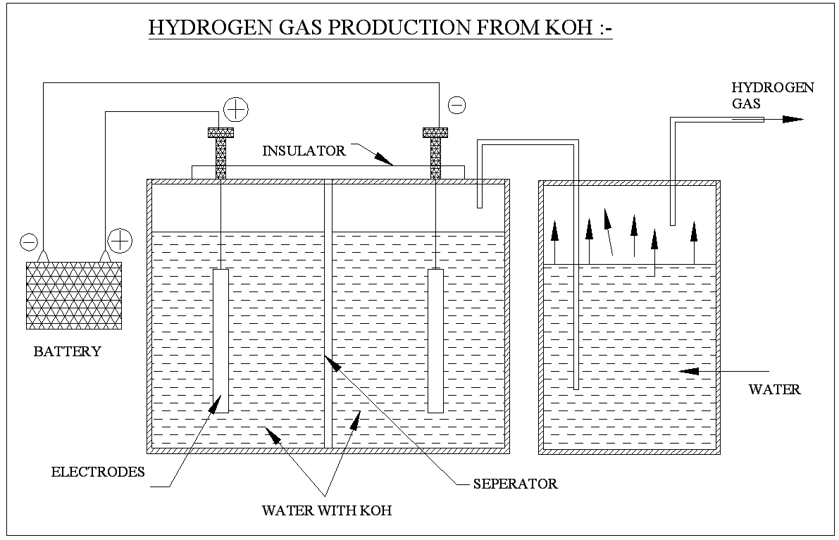
Figure 1 Hydrogen Gas Production from Koh
KOH + H₂O = KOOH + H₂
The balanced equation is
2KOH + 2H₂O = 2KOOH + 2H₂
Notice the free Hydrogen gas 2H₂ which is stripped from the water added to the KOH. Making this reaction more than a one-time event is the key to cheap hydrogen production, which means controlling the reverse reaction to recover the KOH without giving back the hydrogen. Thus, heating the KOOH in a solar cooker will produce the following reaction: KOOH + HEAT --> KOH + O. The balanced reaction is 2KOOH + HEAT --> 2KOH + O2 Notice the free Oxygen gas released in this reaction.
The combined result of our double reaction cycle is the splitting of H₂0 into 2 free gases, and our initial Potassium Hydroxide is ready to be used again. Furthermore, not only have we created a fuel supply, but also an oxygen supply. Designing a continuous fuel supply system from this reaction cycle would require 2 potassium hydroxide tanks. One for each reaction they would have to be exchanged between reactions on a regular timed schedule. Hydrogen production can be regulated with a flow control value from the H₂O storage tank. O₂ production is regulated by heat input. Matching gas production with consumption would reduce the size of tanks needed for surplus gas storage. I haven’t done the exact calculations on how much potassium hydroxide is needed to supply the average gas requirements per capita consumed in the US, but I am guessing that it wouldn’t require very many pounds of KOH, so the system size could be pretty small. The solar collector for the oxygen reaction would probably be the biggest component, and I suggest a focusing solar collector be used for higher heat input. There you have it, a non-polluting source of free hydrogen and oxygen from nothing but the Sun and water.
5.4. Combustion effects in hydrogen fuelled engine systems
It has been adequately emphasized earlier that hydrogen fuel possesses some properties which are uniquely different from the corresponding properties of conventional hydrocarbon fuels. In hydrogen several abnormal combustion they are (3)
- Abnormally high pressure rise.
- Occurrence of pre-ignition in combustion chamber and sequential advancement of pre-ignition and back fire into intake manifold

It has usually been found that the two conditions occur under heavy load conditions. These often causes engine to stop. In this case the gasoline is stored in a petrol tank. This fuel is given to the input of the carburetor through the pump. Before given to the carburetor the petrol and Hydrogen gas is mixed in the proper ratio so that the vehicle runs continuously. This may avoid the abnormal combustion that caused by hydrogen fuel only.

5.5. Properties of fuel

When we use the hydrogen as a fuel we can Reduce Dependence on Fossil Fuels it is Environment friendly fuel so we can reduces air pollution and also it is renewable in nature it is a Carbon less Fuel, Higher Energy Content on Weight Basis and it have Higher Octane Rating,table 1 shows the property of the fuels

Table 1 Ignition And Flammability Properties:
(3)
s.no | Description | H₂ | CH₄ | Gasoline
1 | Minimum ignition energy (mj) | 0.02 | 0.28 | 0.25
2 | Ignition temperature (k) | 858 | 810 | 530
3 | Adiabatic flame temperature(k) | 2384 | 2227 | 2270
4 | Limits of flammability(% in air) | 4.1-75 | 4.3-15 | 1.5-7.6
5 | Maximum laminar flame  velocity (cm/sec) | 270 | 38 | 30
6 | Diffusivity (cm²/sec) | 0.63 | 0.20 | 0.08
6. Emission Control
Using the H₂ as an blended fuel, it will reduce, hydro carbon and carbon monoxide, due to Carbon less Fuel hydrogen is blended with gasoline and also
Hydrogen has a wide flammability limits which permit its use under lean condition, Due to wide flammability limits, pre-ignition on hot cylinder walls can occur,Flame speed for H₂ is seven times higher than that of gasoline, thus approaching the ideal constant volume cycle, Ignition energy is ~1/10 that of gasoline.
7. Design of water fuel engine
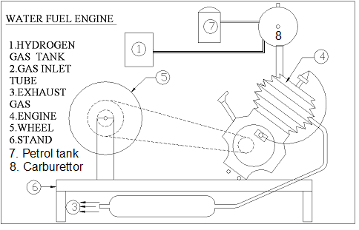
Figure 2 Design of Water Fuel Engine
The general principle of this engine is founded upon the property, which hydrogen gas mixed with atmospheric air possesses, of exploding upon ignition, so as to produce a large imperfect vacuum. If two and a half measures, by volume, of atmospheric air are mixed with one measure of hydrogen, and a flame applied, the mixed gas will expand into a space rather greater than three times its original volume. The products of the explosion are: a globule of water, formed by the union of the hydrogen with the oxygen of the atmospheric air and a quantity of nitrogen, which in its natural state (density=1) constitutes 0.556 of the mixed gas, by volume. The same quantity of nitrogen is now expanded into a space somewhat greater than three times the original volume of the mixed gas; that is, into about six times the space which it previously occupied: its density relative to the atmosphere is therefore about 1/6. If the external air is prevented, by a proper apparatus, from returning into this imperfect vacuum, the pressure of the atmosphere may be employed as a moving force, nearly in the same manner as in a steam-engine: the difference being chiefly in the manner of forming the vacuum.(4),The design of water fuel engine is designed in the figure 2, When starting the engine, fuel flows from the tank to the carburetor, and also at the same time the hydrogen flows through the carburetor from the battery that is filtered by the water and both the gas and fuel is properly mixed inside the carburetor with the air that from air filter and allow in to the combustion chamber due to vacuum creation inside the crank case, thus the engine starts.
8. Conclusion
It is already well- known that the pre-ignition reactivity and consequent backfire of hydrogen fuel demonstrate totally different characteristics in engine operation as against other thermal systems. There has been a spate of interest all over the world on hydrogen engine research and even some of reputed automobile industries are contemplate hydrogen fuelled engines. In this sector which is in horrible need of a non-polluting originator, free from the threat of fuel crisis.
9. Reference
1. "Wind-to-Hydrogen Project". Hydrogen and Fuel Cells Research. Golden, CO: National Renewable Energy Laboratory, U.S. Department of Energy. September2009. Retrieved 7 January 2010.
2. Kevin Fitzgibbons Presented to the United Nations University International Conference Executive Director, Office of the National Science Advisor Ottawa, Canada November 7-9, 2005 Maastricht, Netherlands
3. L.M.DAS “Hydrogen Oxygen Reaction Mechanism Ant Its Implication to Hydrogen Combustion Engine” centres of energy studies IIT Delhi revised published 15 December 1995.
4. The Rev. W. Cecil 1820 on the application of hydrogen gas to produce a moving power in machinery,

